Course: Data Science Roll No: TYCS-12

Aim: Practical on Time-series forecasting.

__________________________________________________________________________________

Output 1

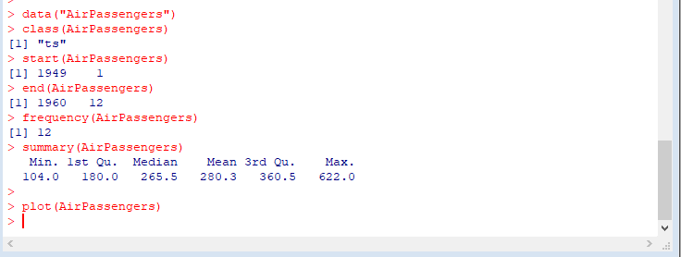

Output 2

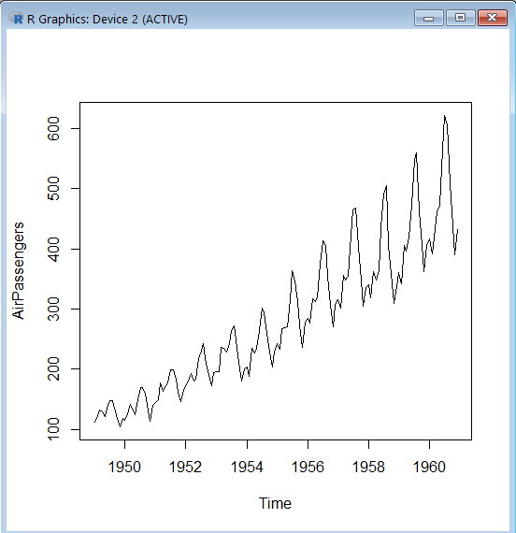

Output 3

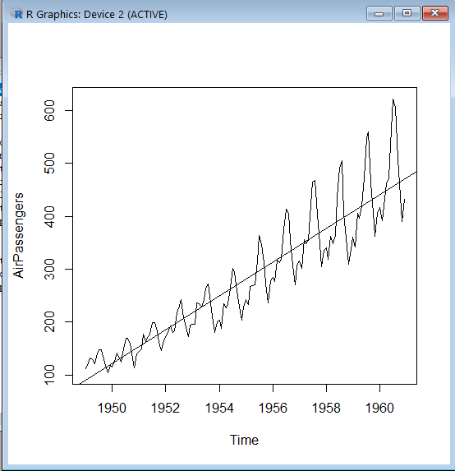

Output 4

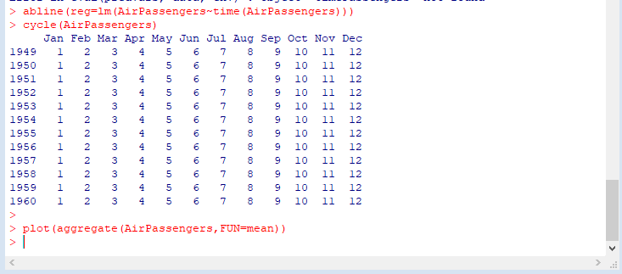

Output 5

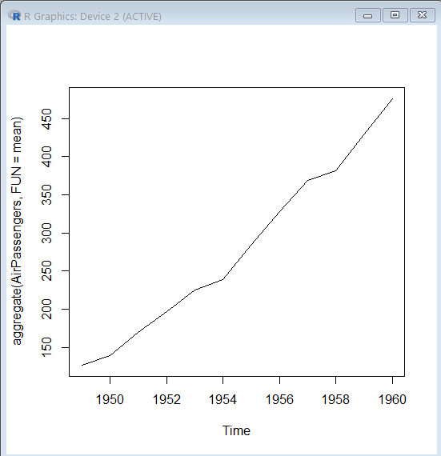

Output6

